

FACULTY OF TECHNOLOGY AND ENGINEERING

DEVANG PATEL INSTITUTE OF ADVANCE TECHNOLOGY AND RESEARCH
DEPARTMENT OF INFORMATION TECHNOLOGY

A.Y. 2026-27 [ODD]

LAB MANUAL

CSUC201:FDSA


Practical 5

Practical 5.1

A music player maintains a playlist where songs can be added to the beginning, added to the end, or inserted right after a specific song that is currently playing. When a song is removed, only the first song in the playlist is dropped. At any point the player can count how many songs are in the playlist and display them from first to last. Given a sequence of such operations, implement all of them on a doubly linked playlist and print the result after each operation. Describe how your insertion after a given song works. What extra step does a doubly linked list require here that a singly linked list did not? What happens if the given song is not found in the playlist?

Code:

https://github.com/kathanpatel2407/FDSA-Batch-B/tree/main/practical%205

Output:

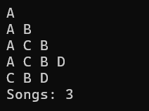

Problem Faced:

In this Practical I faced the issue on how to create a linked list and using the linked list how we can use it to insert the data at a particular node

Key Question

A doubly linked list maintains two links per node instead of one. When deleting the front node, explain why having a backward link on the second node creates a responsibility that did not exist in a singly linked list — and what goes wrong if you forget to handle it.

In a doubly linked list, each node has both next and previous links. When deleting the front node, we update the head to point to the second node, but we must also set the second node’s previous pointer to NULL. This does not exist in a singly linked list because it has no backward link. If we forget to update the previous pointer, the second node will still point to the deleted node, creating a pointer that can cause invalid memory access, list corruption, or a program crash.

Practical 5.2

A group of students are sitting in a circle playing a passing game. A token starts at the first student and is passed around the circle one student at a time. Students can join the circle at any position and leave at any time, and the circle must remain unbroken after every join or leave. Given a sequence of join, leave, and display operations, implement them on both a singly circular and a doubly circular linked list and print the current circle after each operation. Describe how your solution ensures the circle stays unbroken after a student leaves. What is the one case where breaking the circle is most likely to happen as a bug, and how did you handle it?

Code:

https://github.com/kathanpatel2407/FDSA-Batch-B/tree/main/practical%205

Output:

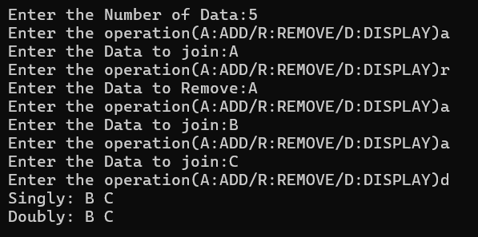

Problem Faced

In this Practical I faced the error on how to create a circular linked list and how to traverse in the linked list as it can run infinitely as it’s a circular linked list and It will always point to next node so instead of for loop I used do-while loop.

Key Question

If your traversal of the circular list does not stop at the right moment, it will loop forever. Without referencing any specific code, explain what condition must be true at the moment you stop, and why that condition would fail if you set the last node's link to null.

In a circular linked list, traversal should stop when you reach the starting node again, because the last node points back to the first node. This condition confirms that you have visited the entire list exactly once. If the last node’s link were set to NULL, the list would no longer be circular, so traversal would reach NULL instead of returning to the starting node. Therefore, a stopping condition based on reaching the first node again would never occur, causing the traversal to continue indefinitely.

